The Doctoral Committee of the Albert Szent-Györgyi Medical School,

University of Szeged invites you to the open defense of the Ph.D. thesis of

**Marah Muwaffaq Ibrahim Freiwan**

Biochemistry, Biophysics, Molecular and Cellular Biology PhD Program,

Doctoral School of Multidisciplinary Medical Sciences,

Program head: Prof. Dr. László Dux DSc

Supervisors: **Dr. Márta Sárközy PhD and Prof. Dr. László Dux DSc**

entitled

***„*Investigation of the antiremodeling effects of losartan, mirabegron and their combination on the development of doxorubicin-induced chronic cardiotoxicity in a rat model*”***

**on May 16th, 2022 at 14:00**

**at “SZAB Székház” (Szeged, Somogyi utca 7.)**

Chair of the Evaluation Board: **Prof. Dr. András Varró DS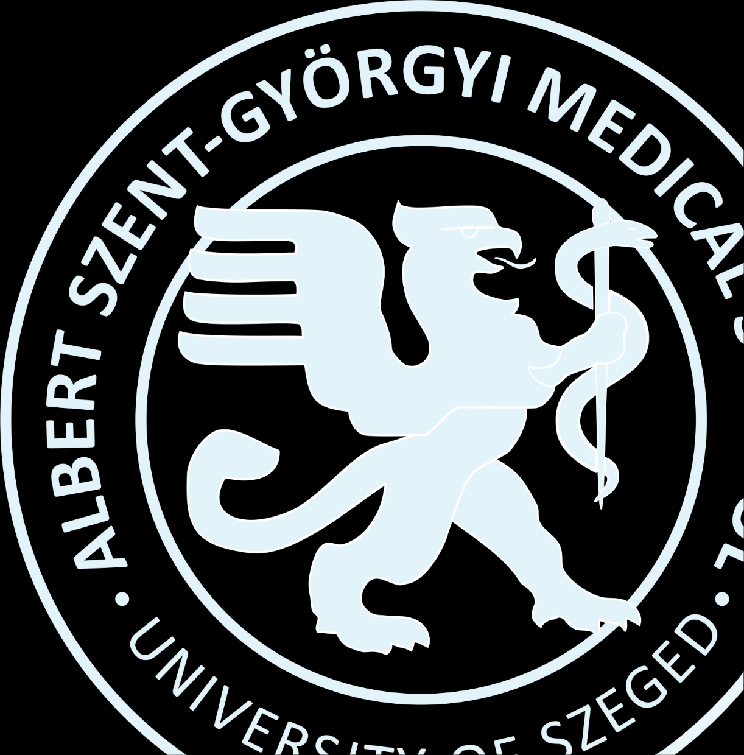c**

Albert Szent-Györgyi Medical School, University of Szeged, Dept. Pharmacology and Pharmacotherapy

Official Opponents: **Dr. Gabriella Fábián PhD**

Albert Szent-Györgyi Medical School University of Szeged, Dept. of Oncotherapy

**Dr. Zoltán Varga PhD**

Semmelweis University, Faculty of Medicine, Dept. of Pharmacology and Pharmacotherapy

Members of the Board: **Dr. Melinda Tóth PhD**

Eötvös Loránd Research Network, Biological Research Centre, Szeged Centre of Excellence of the European Union

Secretary: **Dr. József Kaszaki PhD**

Albert Szent-Györgyi Medical School, University of Szeged, Institute of Surgical Research

Albert Szent-Györgyi Medical School, University of Szeged